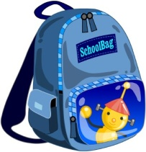

2022-2023 SCHOOL YEAR
SCHOOL SUPPLIES -
Pre-School - 6th Grade
PRE-SCHOOL  Glue Sticks  Crayons  Pencils  Colored Pencils  Pencil case  Big Rule Paper  Hand Sanitizer  KINDERGARTEN  Glue Sticks  Crayons  Colored Pencils  Pencils  Markers  1 pair Children’s Scissors  Hand Sanitizer | 4th GRADE  1” 3 Ring Binder Yellow Highlighter  Dividers for Binder 2 Black Sharpies  Paper for Binder Ruler  Glue Sticks Eraser  Pencils Colored Marker  Pencil Case Pencil Sharpener  Colored Pencils  Hand Sanitizer  Hand Sanitizer  Scissors
1st GRADE  #2 Pencils  Colored Pencils  Pencil Case  Glue Sticks  Crayons  Dry Erase Markers  Disinfecting Wipes  Hand Sanitizer | 5th GRADE  1 x 3” binder Scissors  Dividers for Binder Ruler  Paper for Binder Highlighters  Pencils Glue Sticks  Pencil Case Pencil Sharpener  Colored Pencils  Colored Markers  Hand Sanitizer  Black Sharpies
2nd GRADE  #2 Pencils  Pencil Case  White Erasers  Colored Pencils  Crayons  Scissors  Glue Sticks  Highlighters  1 package Wide Ruled Lined Paper  Hand Sanitizer | 6th GRADE  1 x 2” binder Hand Sanitizer  Dividers for Binder Scissors  Paper for Binder Glue Sticks  Pencils Yellow Highlighters  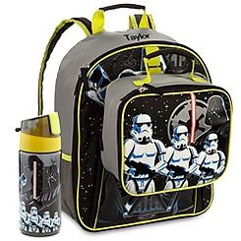  Colored Pencils Pencil Sharpener  Colored Markers  Pencils  Pencil Case
3rd GRADE  Pencils  Pencil Case  Pencil Sharpener  Crayons  Scissors  Glue Sticks  White Erasers  Ruler  Washable Markers  Hand Sanitizer  Yellow Highlighter | 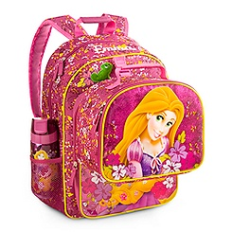  KID POWER!

2022-2023 SCHOOL YEAR

7TH THROUGH 12TH GRADE

- Flash Drive  - Calculator (Scientific)  - Compass (for Math)  - Protractor  - Day Planner  - Dictionary  - Paper  - Mechanical Pencil & Lead  - Report Cover (with Pockets)  - Graph Paper  - Notebook Paper  - Spiral Notes (5) each  - Index Cards (3x5 & 4x6)  - Binder 2” & 4”  - Glue Stick  - Ruler  College Student  - Flash Drive  - Calculator (Scientific)  - Day Planner/ Calendar Book  - Paper  - Mechanical Pencil & Lead  - Report Cover (with Pockets)  - Graph Paper  - Notebook Paper  - Spiral Notes (5) each  - Index Cards (3x5 & 4x6)  - Binder 2” & 4”  - Backpack ( Black or Blue)  Contact: Jean Morgan- Community Outreach Director  (510) 252-0910 ex 804 Email:jmorgan@abodeservices.org | - Eraser  - #2 Pencils  - Color Pencils  - Pencil Sharpener  - Paper Clips  - Mini Staplers  - Scissors  - Pencil Pouch  - Post It Notes  - Paper Clips  - Markers  - Highlighters  - Pens (Black or Blue)  - Scotch Tape  - Hand Sanitizer  - Kleenex

